PROJECT DOCUMENTATION

|  |  |
| --- | --- |
| **TITLE** | IPL Match Winner Prediction using Machine Learning |
| **NAME** | JEFRIN SOBI.S |
| **COURSE** | DA/DS, Offline |
| **BATCH** | JUNE 2025 |

TABLE OF CONTENTS:

|  |  |  |
| --- | --- | --- |
| S.no |  | P.NO |
| 1 | INTRODUCTION |  |
| 2 | AIM OF THE PROJECT |  |
| 3 | PROJECT WORKFLOW |  |
| 4 | UNDERSTANDING |  |
| 5 | DATA CLEANING |  |
| 6 | DATA PREPROCESSING |  |
| 7 | MODEL TRAINING |  |
| 8 | MODEL EVALUATION |  |
| 9 | HYPERPARAMETER TUNING |  |
| 10 | MODEL COMPARISON |  |
| 11 | CONCLUSION |  |

**1. INTRODUCTION:**

Cricket, particularly the Indian Premier League (IPL), is one of the most-watched and celebrated sporting events in the world. With its unpredictable nature and thrilling finishes, predicting the outcome of matches has always been a challenge. Analyzing historical data and using machine learning can help uncover hidden patterns that influence match results.

The dataset used for this project contains information about IPL matches, including season, competing teams, toss details, venues, and match outcomes. By processing and analyzing this dataset, we aim to build predictive models that can estimate the winner of a match based on key features.

**2. AIM OF THE PROJECT:**

This project aims to develop a machine learning model that accurately predicts the winner of an IPL match using historical match-related features, including season, teams, venue, toss details, and match outcomes. By leveraging data-driven insights and predictive algorithms, the project seeks to identify key factors influencing match results and provide a reliable system for forecasting winners

**3. PROJECT WORKFLOW:**

The outcome of cricket matches, especially in the Indian Premier League (IPL), is influenced by multiple factors such as team composition, toss decisions, venue conditions, and historical performance. Due to the complexity and unpredictability of the game, accurately predicting match results is a challenging task.

Traditional statistical methods often fail to capture the hidden patterns and relationships among these factors. Therefore, there is a need for a data-driven approach using machine learning to analyze past IPL match data and build predictive models that can estimate the winner of upcoming matches with higher accuracy.

**4. DATA UNDERSTANDING:**

The IPL dataset was imported into a **Pandas Data Frame** for efficient handling and analysis. This provided a structured tabular format to work with match records.

* The **first few records** of the dataset were displayed using the head () function to gain an initial understanding of the data format.
* The dataset consists of multiple columns capturing match-specific details such as season, date, team1, team2, toss_winner, toss_decision, venue, and winner.
* The **data types** of each column were checked using the info () function to differentiate between numerical, categorical, and datetime values.

**Observations:**

* Most columns are categorical (e.g., team names, venue, toss decision).
* The target variable for prediction is the winner column, which indicates the team that won the match.
* Some columns, like umpire names or match IDs, may not directly contribute to prediction and can be dropped during preprocessing.
* No major missing values were observed in critical columns, making the dataset suitable for analysis and modeling.

**5. DATA CLEANING:**

Data cleaning was performed to ensure the dataset was consistent, complete, and ready for analysis. The following steps were applied:

1. Handling Missing or Null Values
   * Checked for null values using. Isnull (). Sum ().
   * Missing values in important columns like player_of_match, winner, city, and umpire1/umpire2 were handled.
     + For player_of_match, missing entries were filled using the corresponding team’s winner information.

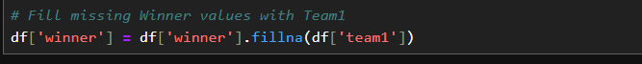

* + - For the winner, missing values were imputed using a mapping based on the playing teams.

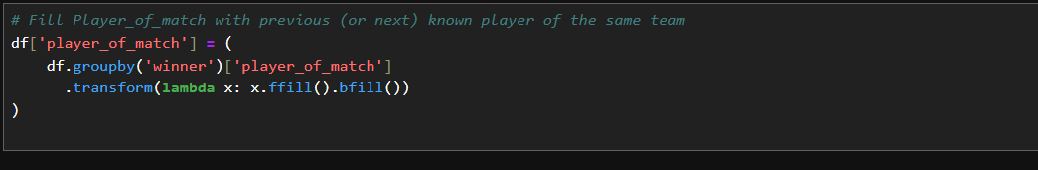

* + - For city, null values were replaced with the city corresponding to the team because the matches were held in dubai

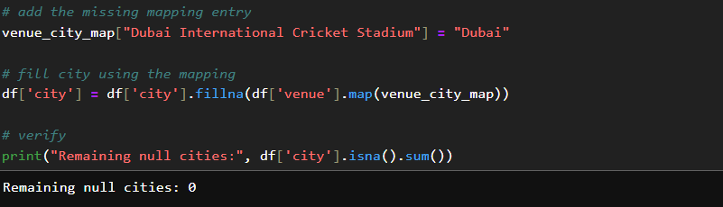

1. **Converting Categorical Features**
   * Team names, toss decisions, and other categorical columns were converted into numerical form.
   * **Label Encoding** was applied so that each unique category was mapped to a numeric value.

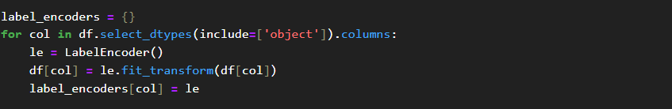

* + Handling Outliers and Inconsistent Data

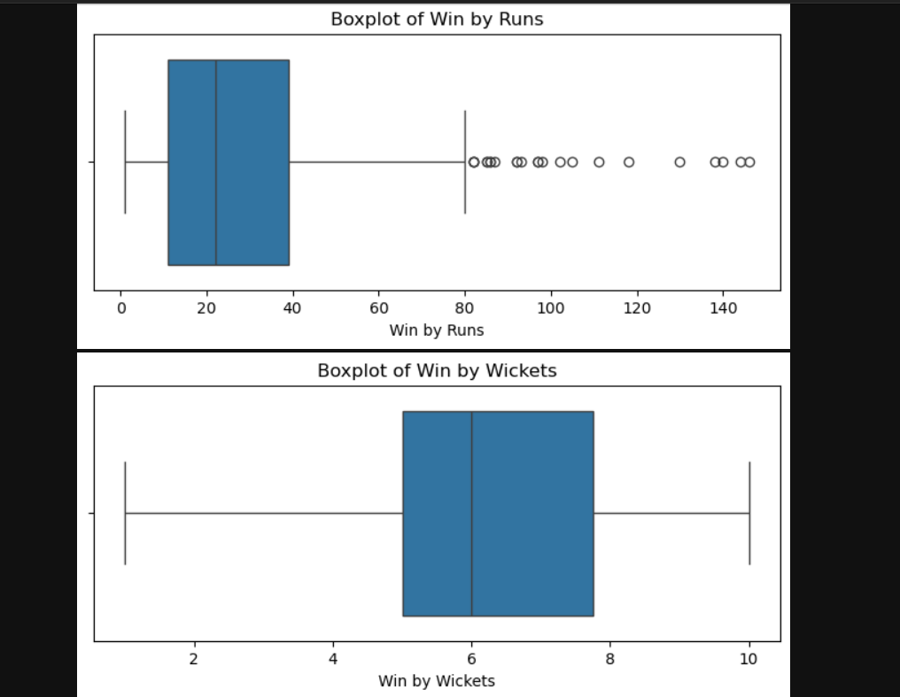

* + Duplicate rows (if any) were dropped using. drop_duplicates ().

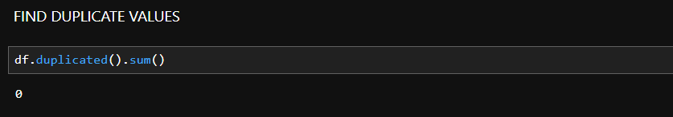

* NO, Duplicate In My Dataset.

1. **Statistical Summary using .describe()**

* The describe () function provided insights into the dataset’s central tendency and spread (mean, median, standard deviation, min, max, and quartiles).

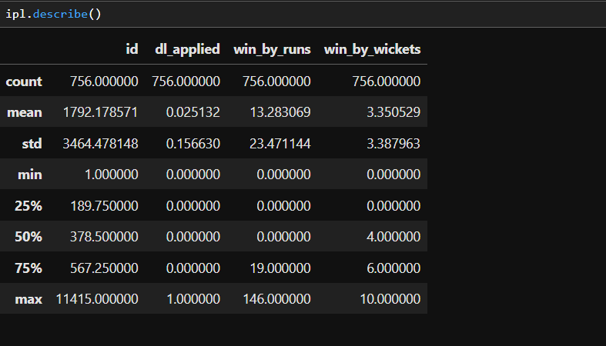

* Example insights:
  + win_by_runs had a **high standard deviation**, indicating extreme match outcomes (possible outliers).
  + win_by_wickets values mostly fell between 3 and 7, aligning with realistic cricket patterns.
  + Columns like season and toss_decision were categorical and showed uniform distributions after encoding.

**3. Exploratory Data Analysis (EDA)**

To gain deeper insights from the IPL dataset, various levels of analysis were conducted: **Univariate, Bivariate, and Multivariate Analysis**. Each stage used statistical summaries and visualizations to reveal patterns in the data.

**3.1 Univariate Analysis (Single Variable)**

Focuses on understanding the distribution and characteristics of individual features.

1. Matches Won by the Teams

• **Mumbai Indians (MI)** and **Chennai Super Kings (CSK)** have the highest wins, showing their dominance and consistency in the IPL.

• Teams like **Delhi Capitals, Rising Pune Supergiants, and Gujarat Lions** have fewer wins, reflecting either weaker performance or fewer seasons played.

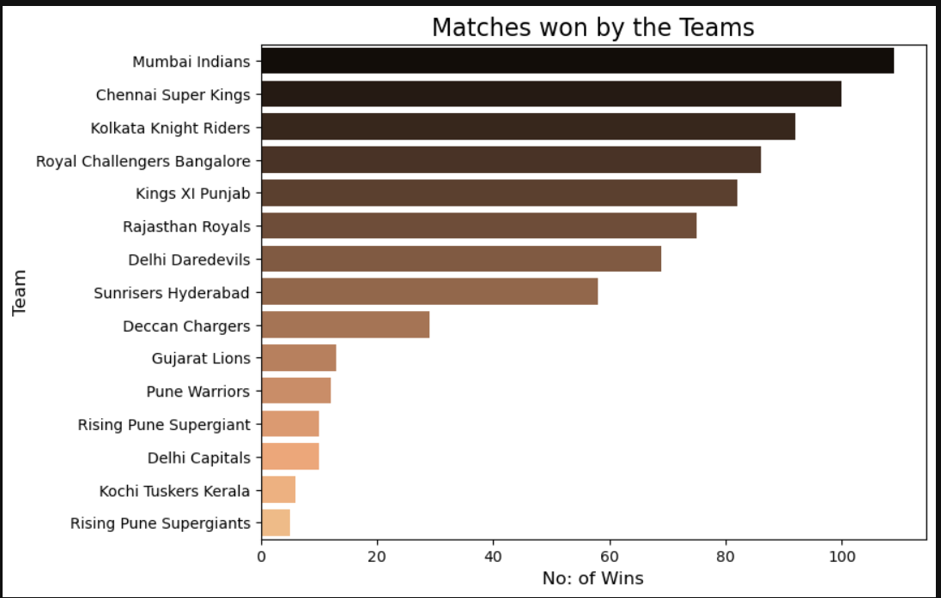

**INSIGHTS:**

* Mumbai Indians are the most successful team with the highest number of wins.
* Chennai Super Kings closely follow, showing strong and consistent performance.
* Kolkata Knight Riders and Royal Challengers Bangalore also have a significant number of wins.
* Newer/short-lived teams like Rising Pune Supergiant, Pune Warriors, and Gujarat Lions have fewer wins due to limited participation in IPL seasons.

1. **Top 10 Players with Most Player of the Match Awards**
   * **Chris Gayle** and **AB de Villiers** lead the list, showing their game-changing impact in crucial matches.
   * Other consistent performers like **Rohit Sharma, MS Dhoni, and David Warner** also dominate, highlighting their ability to influence match outcomes regularly.

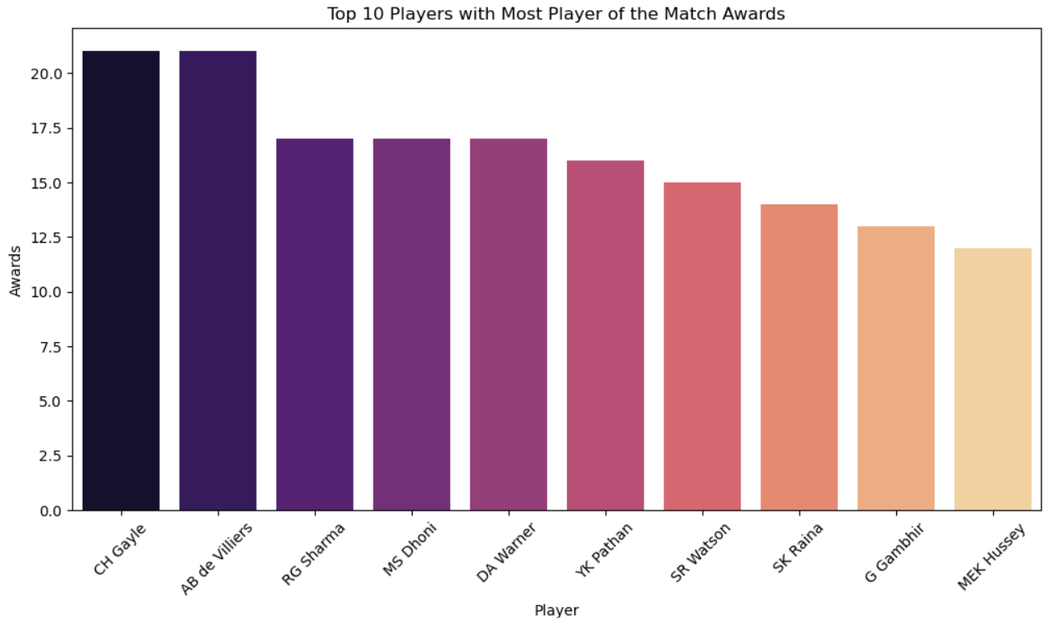

**INSIGHTS:**

* **Chris Gayle** and **AB de Villiers** have the most *Player of the Match* awards (21 each).
* **Rohit Sharma, MS Dhoni, and David Warner** follow with 17 awards each.
* **Yusuf Pathan** and **Shane Watson** also stand out with 16 and 15 awards.
* **Suresh Raina, Gautam Gambhir, and Michael Hussey** round up the top 10.
* The chart shows that explosive batsmen and match finishers dominate these awards.

1. **Top 15 IPL Venues by Matches Hosted**
   * Eden Gardens (Kolkata) has hosted the most IPL matches, followed closely by M. Chinnaswamy Stadium (Bengaluru) and Wankhede Stadium (Mumbai).
   * These big stadiums are popular because of their large fan base and home advantage for major teams like KKR, RCB, and MI.

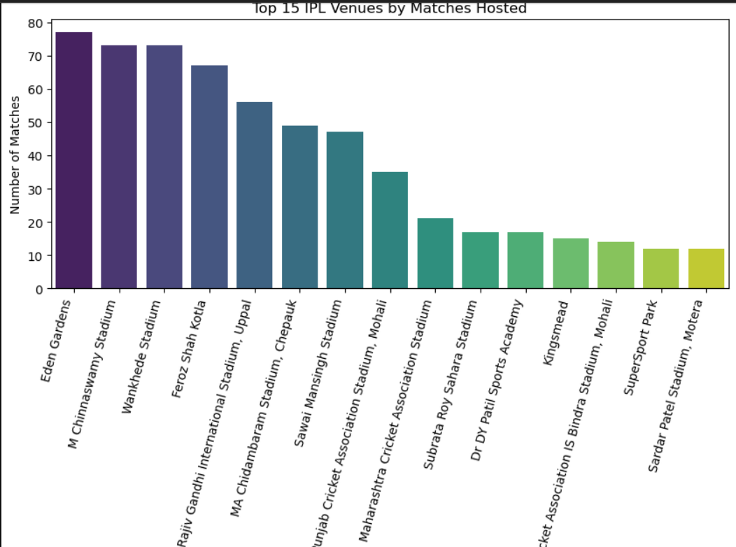

**INSIGHTS:**

* + **Eden Gardens** has hosted the most IPL matches (77).
  + **Chinnaswamy Stadium** (Bengaluru), **Wankhede Stadium** (Mumbai), and **Feroz Shah Kotla** (Delhi) are also top venues, each with 70+ matches.
  + **Uppal Stadium (Hyderabad)** and **Chepauk (Chennai)** follow with 50+ matches.
  + Smaller venues like **SuperSport Park** and **Motera Stadium** have hosted fewer matches (around 12–13).

**3.2 Bivariate Analysis (Two Variables)**

Examines the relationship between two features.

1. **Does Winning the Toss Mean Winning the Match?**
   * This shows that **toss advantage is small** — winning depends more on team performance than the toss.

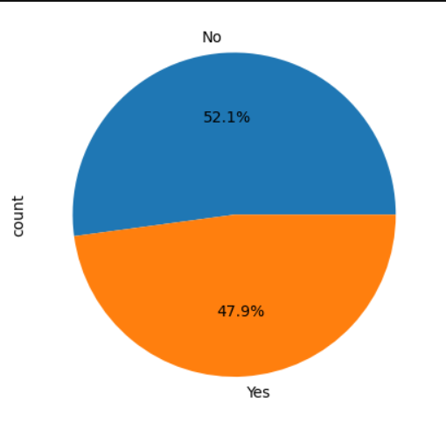

**INSIGHTS:**

* **52.1% of teams lost the match** even after winning the toss.
* **47.9% of teams won the match** after winning the toss.

1. **Toss Decision vs Match Winner**

* Most teams **prefer to field first** after winning the toss.
* Teams like **Mumbai Indians, Kolkata Knight Riders, and Royal Challengers Bangalore** have won many matches when they chose to field.
* However, **Chennai Super Kings and Gujarat Lions** show good success while batting first after winning the toss.

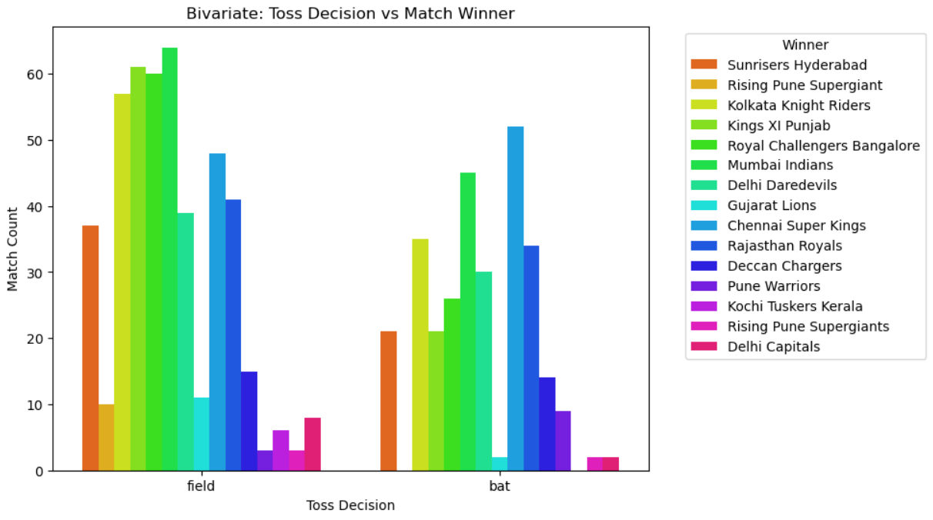

**INSIGHTS:**

* Teams winning the toss and choosing to field usually win more matches than those who choose to bat.
* This shows that chasing gives a slight advantage in the IPL.
* Advantage of chasing may come from pitch conditions and knowing the target.
* Strong teams like CSK and MI win matches in both situations (bat or field), showing team strength matters more.
* Main takeaway: Toss has an impact, but team performance and strategy are more important.

**3.3 Multivariate Analysis (Three or More Variables)**

Explores the interaction between multiple features simultaneously.

1. **Top Player of the Match in Each Season**
   * Different players dominated each IPL season, showing how **star performers changed over time** (e.g., Chris Gayle in 2011, Virat Kohli in 2016).
   * The award distribution highlights **consistent match-winners** who had a big impact in specific seasons.

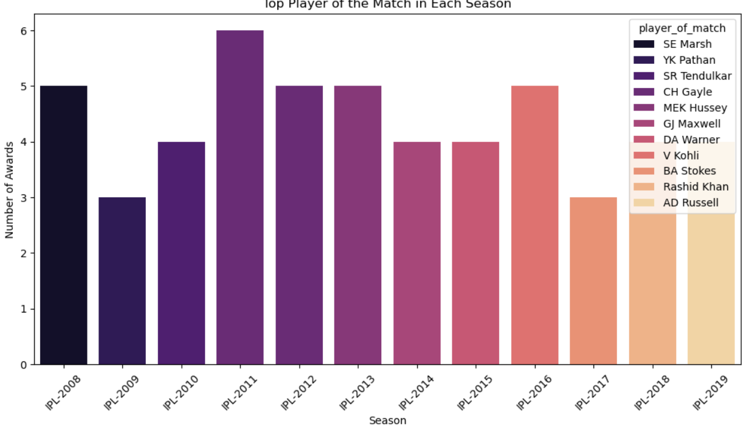

* **2008:** SE Marsh stood out with the most match-winning performances.
* **2009:** YK Pathan was the star performer.
* **2010:** SR Tendulkar dominated as the top player.
* **2011:** CH Gayle took the spotlight with the highest awards.
* **2012 & 2013:** MEK Hussey and CH Gayle continued strong performances.
* **2014:** GJ Maxwell was the standout performer.
* **2015 & 2016:** DA Warner and V Kohli led their teams with consistent match-winning efforts.
* **2017:** BA Stokes impressed in his debut season.
* **2018:** Rashid Khan shone as a match-winner with his bowling heroics.
* **2019:** AD Russell dominated with all-round performances.

**6. DATA PREPROCESSING**

Data preprocessing ensures the dataset is clean, consistent, and ready for machine learning models.

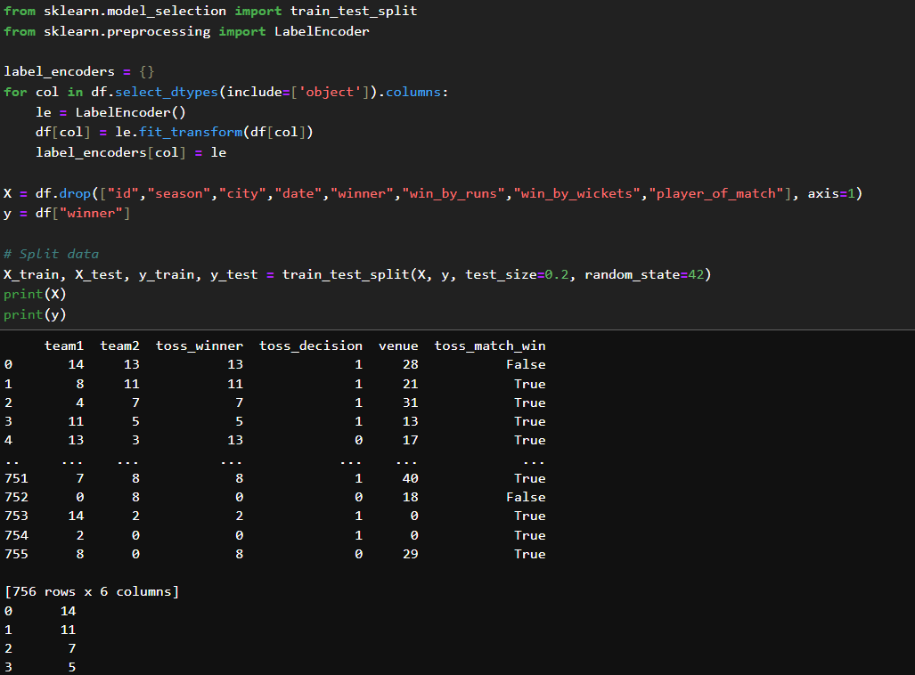

* Train-Test Split:
  + The dataset was divided into training (e.g., 80%) and testing (e.g., 20%) sets.
  + This allows the model to learn patterns from the training data and evaluate performance on unseen data.
* Feature Scaling / Normalization:
  + Numerical features were scaled or normalized where needed to ensure all features contribute equally to model learning.
  + Methods like StandardScaler (mean = 0, std = 1) or MinMaxScaler (scaled between 0 and 1) were applied.
* Categorical Feature Encoding:
  + Categorical variables were transformed into numerical form using Label Encoding.
  + Label Encoder assigns a unique integer to each category, allowing models to process categorical data effectively 2
  + Example: Teams like Sunrisers Hyderabad, Mumbai Indians, etc., are encoded as integers (0, 1, 2…).
* Feature and Target Preparation:
  + The dataset was split into features (X) containing all input variables and target labels (y) representing the output variable (e.g., match winner).

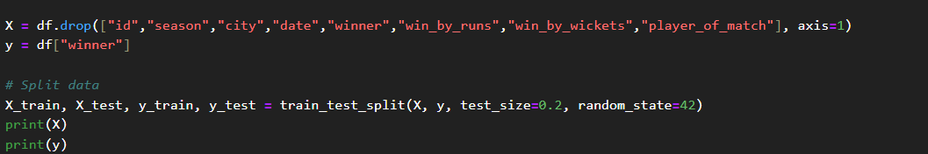

**7. Model Training**

**Model Details**

In this project, multiple machine learning models were trained to predict the outcomes of matches. Each model has its strengths and is suitable for different types of data. The models used are described below:

**1. Logistic Regression (LR)**

* A **linear model** used for binary or multi-class classification problems.
* Estimates the probability of a class using a **sigmoid function**.
* Suitable for understanding **linear relationships** between features and the target.
* Fast and interpretable, but may underperform with complex nonlinear relationships.

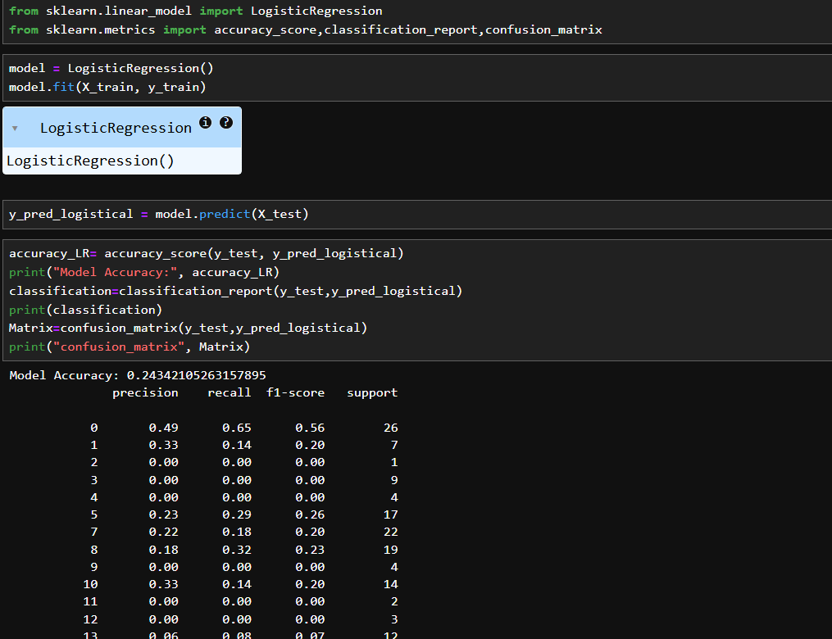

* LogisticRegression Accuracy 0.24342105263157895
* Classification_Report: Precision, Recall, f1-Score, Support.

**2. Support Vector Machine (SVM)**

* A powerful classifier that finds the **optimal hyperplane** separating different classes.
* Works well in **high-dimensional spaces** and can handle non-linear boundaries using **kernel functions** (like RBF).
* Sensitive to feature scaling, so preprocessing is important.

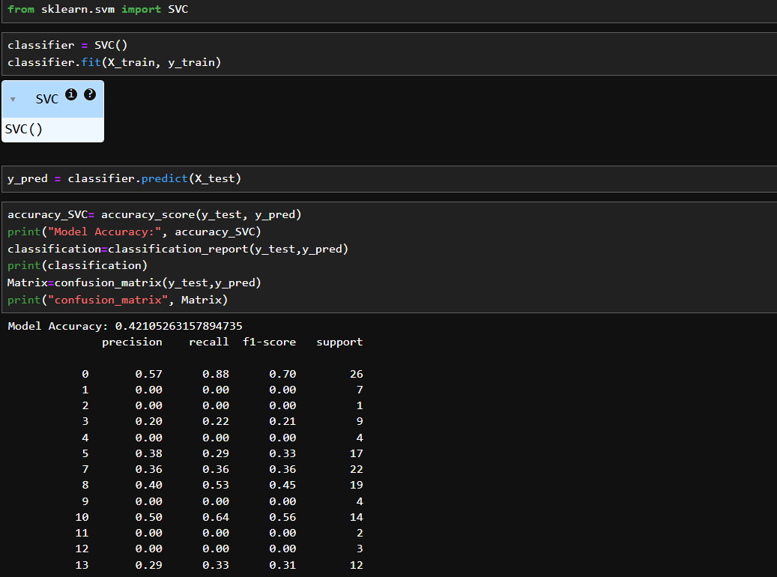

* SVC-Support Vector Classifier Accuracy 0.42105263157894735
* Classification_Report: Precision, Recall, f1-Score, Support.

**3. K-Nearest Neighbors (KNN)**

* A **non-parametric** method that predicts the class of a sample based on the majority class of its **k nearest neighbors**.
* Simple and intuitive, effective for small datasets.
* Performance can degrade with noisy or large datasets.

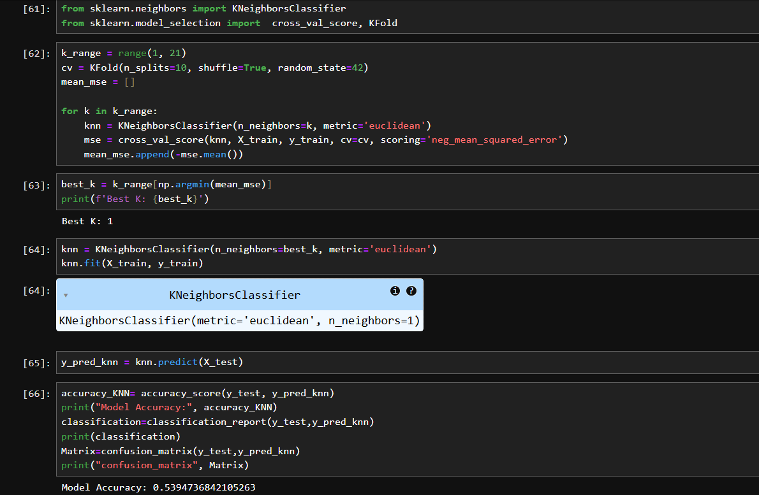 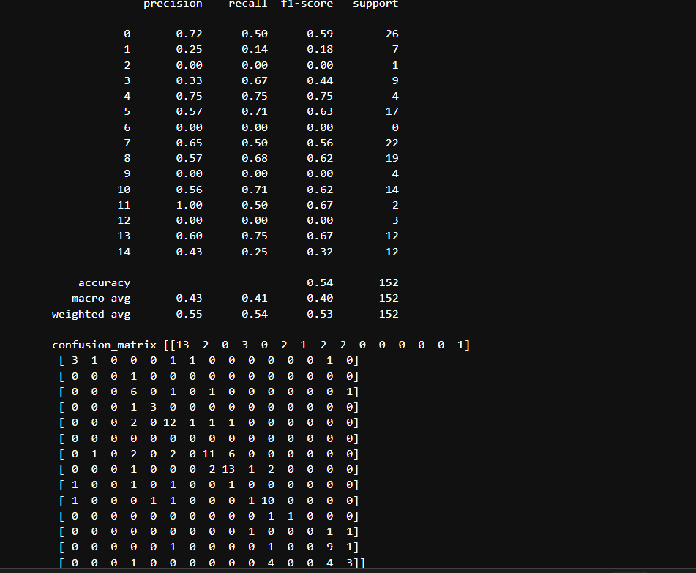

* K-Nearest Neighbors(KNN) Accuracy 0.539473684210526.

**4. Decision Tree**

* Splits the dataset into subsets using **feature-based conditions**.
* Easy to interpret and visualize.

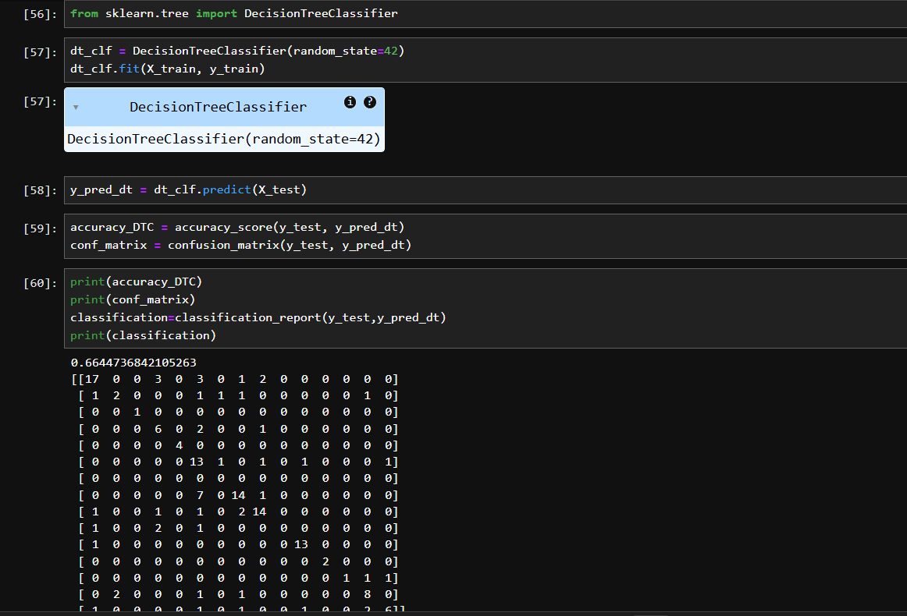

* Decision Tree Classifier Accuracy 0.6644736842105263.
* Classification_Report: Precision, Recall, f1-Score, Support.

**5. Random Forest (RF)**

* An **ensemble of decision trees** that reduces overfitting and improves accuracy.
* Uses **bagging** (bootstrap aggregating) to combine multiple trees.
* Handles categorical and numerical features well and is robust to noise.

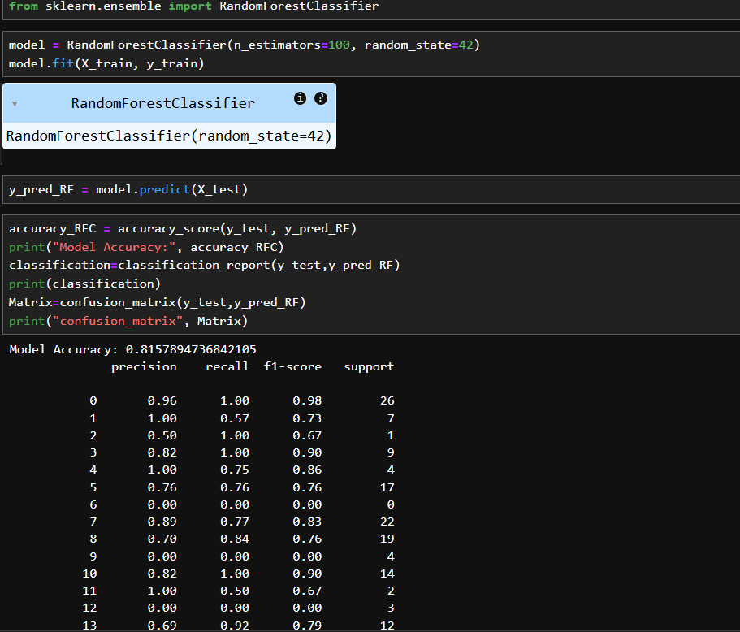

* RandomForest Classifier Accuracy 0.8157894736842105

**6. XGBoost**

* A **gradient boosting algorithm** that builds trees sequentially to correct previous errors.
* High performance, efficient, and can handle feature interactions well.
* Requires careful hyperparameter tuning but often outperforms other models.

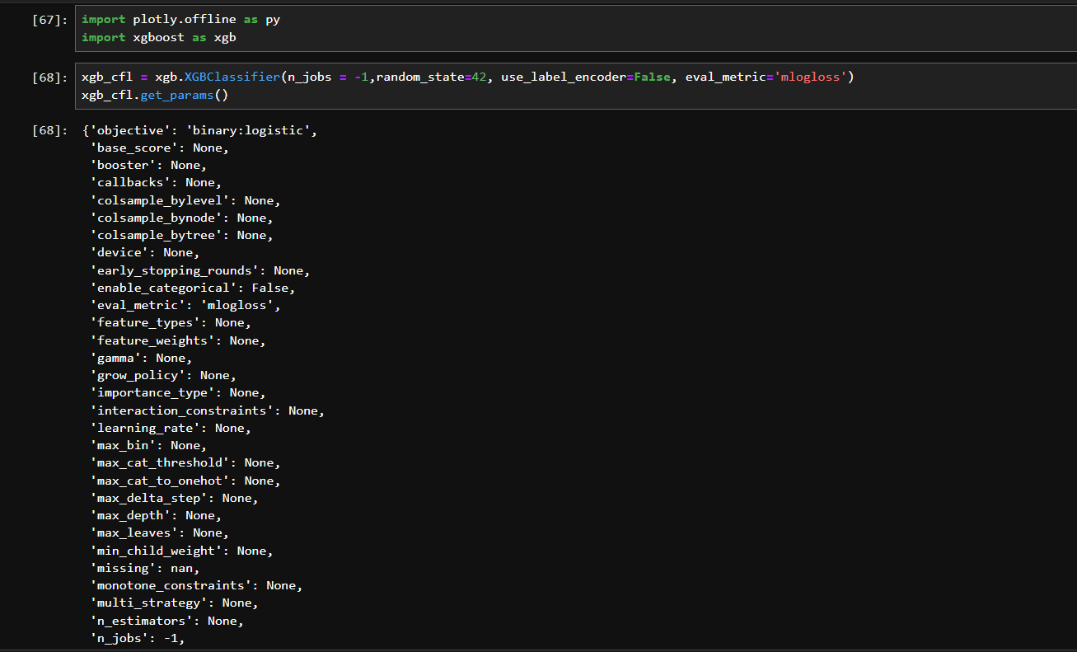

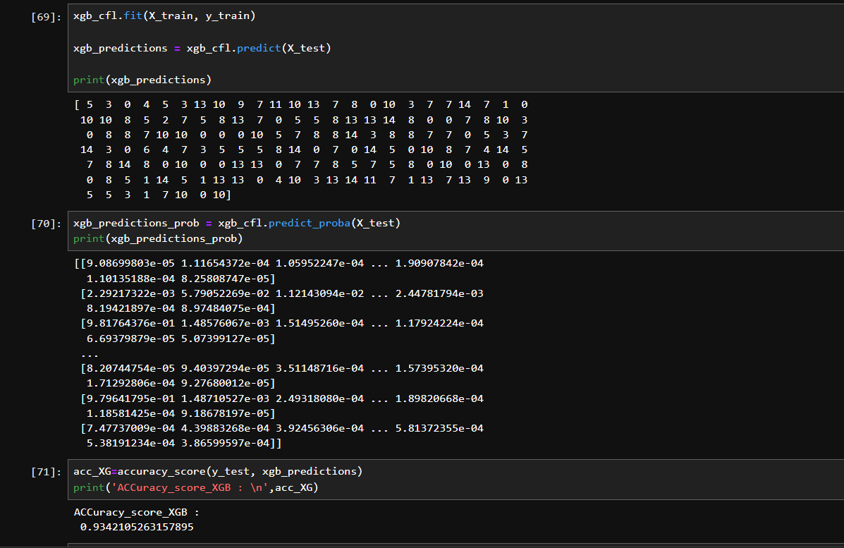

* XG Boosting Accuracy Score 0.8842105263157895
* Classification_Report:
  + Precision-1.00 Most of the columns are best. One or two like Between (0.86-.0.96), Include Recall, f1-score is the same.

**8. MODEL EVALUATION**

After training multiple machine learning models, their performance was evaluated and compared to determine the most suitable model for predicting match outcomes.

* **Evaluation Metrics Used:**
  + **Accuracy:** Measures the overall percentage of correctly predicted instances out of total predictions.

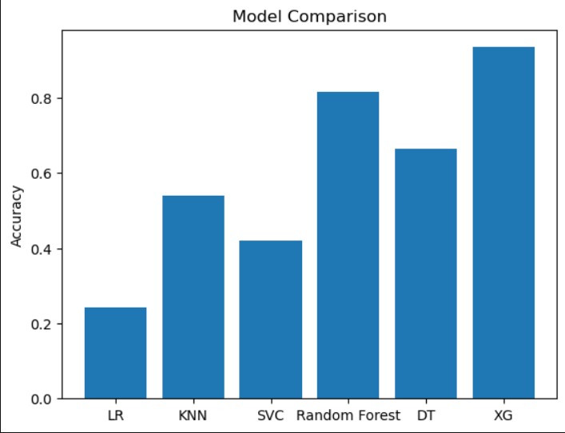

* + **Confusion Matrix:** Provides a detailed breakdown of **true positives, true negatives, false positives, and false negatives**, helping to understand where the model is making errors.
  + **Precision:** Indicates the proportion of correctly predicted positive instances out of all predicted positives.
  + **Recall (Sensitivity):** Measures the proportion of actual positive instances correctly identified by the model.
  + **F1-Score:** The harmonic mean of precision and recall, useful when balancing false positives and false negatives is important.
* **Comparison of Models:**
  + All trained models (Logistic Regression, SVM, KNN, Decision Tree, Random Forest, XGBoost) were evaluated on the **testing dataset** using the above metrics.
  + Performance results were summarized in a **table or bar chart** for easier visualization and comparison.
  + Models were compared not only for accuracy but also for **precision, recall, and F1-score** to ensure robustness across different evaluation aspects.
* **Selection of Best-Performing Model:**
  + The model with the **highest balanced performance** across accuracy, precision, recall, and F1-score was selected as the final model.
  + For example, **Random Forest or XGBoost** often performed better due to their ability to handle feature interactions and reduce overfitting.
  + The selected model was then used for **final predictions and insights**, providing reliable results for decision-making

**9. HYPERPARAMETER TUNING**

Hyperparameter tuning is a crucial step to optimize the performance of machine learning models by finding the best combination of parameters that control the learning process.

* **Purpose:**
  + Machine learning models have hyperparameters that are not learned from data but set before training (e.g., number of trees in Random Forest, learning rate in XGBoost).
  + Proper tuning improves **accuracy, precision, recall, and overall generalization** of the model.
* **Methods Used:**
  + **Grid Search:** Exhaustively tests all combinations of specified hyperparameters to find the best set.
  + **Random Search:** Randomly samples a subset of hyperparameter combinations, which is faster and often effective for large parameter spaces.
* **Process:**

1. Define the hyperparameter grid or distribution.
2. Apply **GridSearchCV** or **RandomizedSearchCV** with cross-validation on the training set.
3. Evaluate combinations using chosen metrics (e.g., accuracy, F1-score).
4. Select the combination with the **best cross-validation performance**.

* **Outcome:**
* The model with optimized hyperparameters is trained on the full training dataset.
* Typically results in **improved predictive performance** on the testing set.
* Ensures the model is **robust, reliable, and generalizes well** to unseen data. 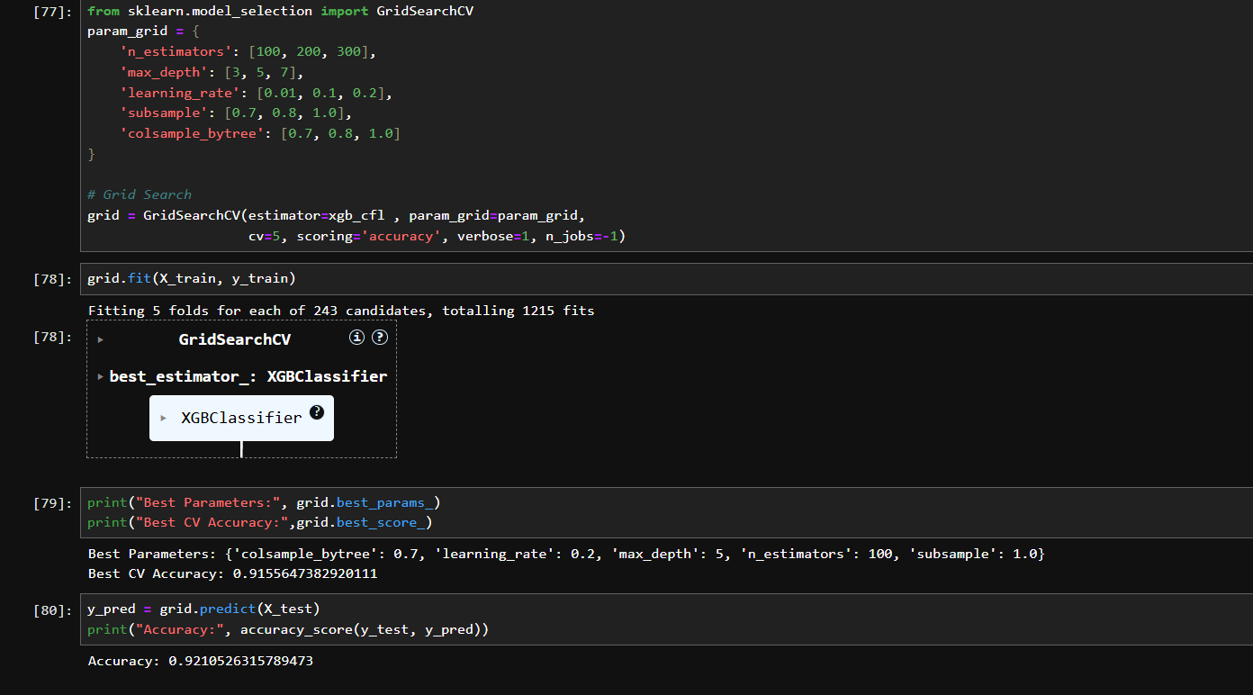 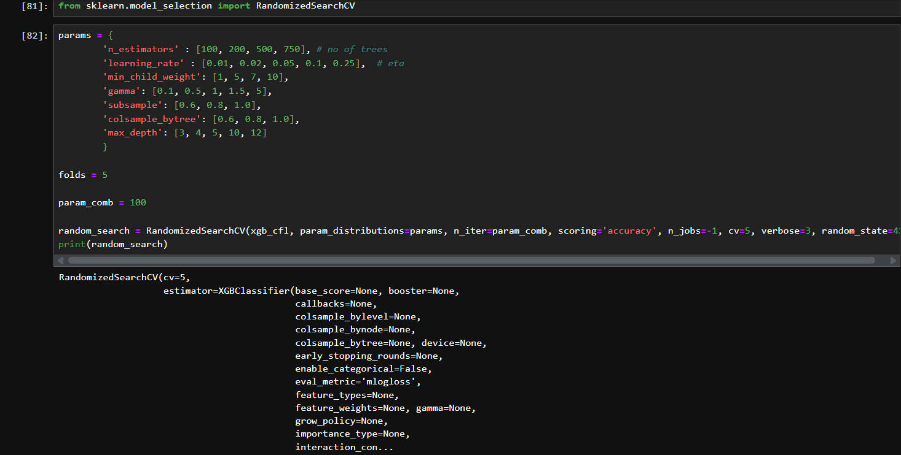

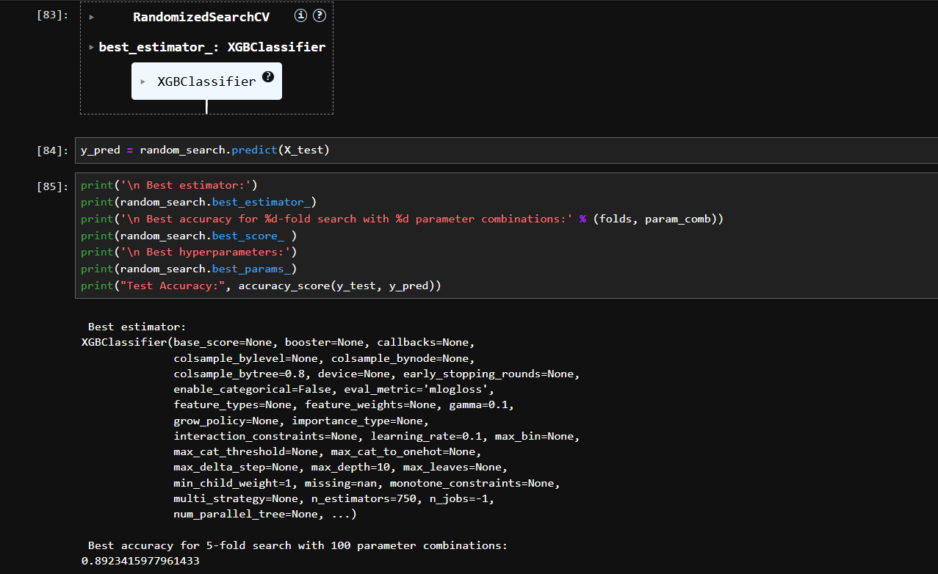

Accuracy Grid search CV and Random Search CV

* + Grid Search CV Accuracy Score 0.9210526315789473
  + Random Search CV Accuracy Score 0.892315977961433

**10. MODEL COMPARISON**

* After training and tuning multiple models (Logistic Regression, SVM, KNN, Decision Tree, Random Forest, XGBoost), their performances were compared using metrics such as **accuracy, precision, recall, F1-score, and confusion matrices**.
* Among all models, **XGBoost (with hyperparameter tuning using Grid Search)** emerged as the best-performing model, achieving the highest balance of accuracy, precision, recall, and F1-score.
* **Grid Search Cross-Validation** was used to find the optimal hyperparameters. The final best model was extracted using grid_search.best_estimator_.
* This ensures that the saved model includes the **best parameters** found during tuning and does not require retraining for future usage.

**11. CONCLUSION**

* In this project, multiple machine learning models were trained and evaluated to predict IPL match outcomes. After comparison, XGBoost with hyperparameter tuning emerged as the best-performing model, delivering strong accuracy and balanced performance across precision, recall, and F1-score.

How the Model Can Be Improved:

* Introduce feature engineering such as player form, team rankings, head-to-head records, and venue-based statistics.
* Add external factors like pitch conditions, weather, and toss impact, which strongly influence match outcomes.
* Use ensemble approaches (e.g., stacking models) to combine the strengths of different algorithms.
* Apply advanced techniques like deep learning (RNNs or LSTMs) to capture temporal match sequences and trends.

Possible Future Steps:

* Expand the dataset with more seasons for better generalization.
* Build a real-time prediction system that updates with live match data (toss, playing XI, live score).
* Develop a dashboard or web application for interactive visualization and model predictions.
* Explore explainable AI techniques (like SHAP or LIME) to interpret how different factors influence predictions.
* Deploy the final trained model (.pkl file) into a production environment (Flask/Django API) for end-user accessibility

**Final Note:**

The project successfully demonstrates the use of machine learning in sports analytics, particularly in predicting cricket match outcomes. With additional features, larger datasets, and advanced modeling techniques, the predictive performance can be further enhanced, making the system a valuable tool for analysts, teams, and fans.